Meta Title: Experience a Magical Dolphin Tour in Naples, FL!

Meta Description: These dolphin tours in Naples, FL will take you on an adventure you'll never forget. See dolphins in their natural environment, swim in clear water, and make memories.

Experience A Magical Dolphin Tour Naples FL

Millions of elegant dolphins glide through the pristine waters of the Gulf of Mexico and you can now witness these magnificent creatures in their natural habitat. There are so many dolphin tours in Naples FL that offer a unique blend of adventure and relaxation.

These tours are perfect for families, couples, and solo travelers. Join us for an unforgettable experience as we explore the beauty of Naples' coastal waters and create memories that will last a lifetime.

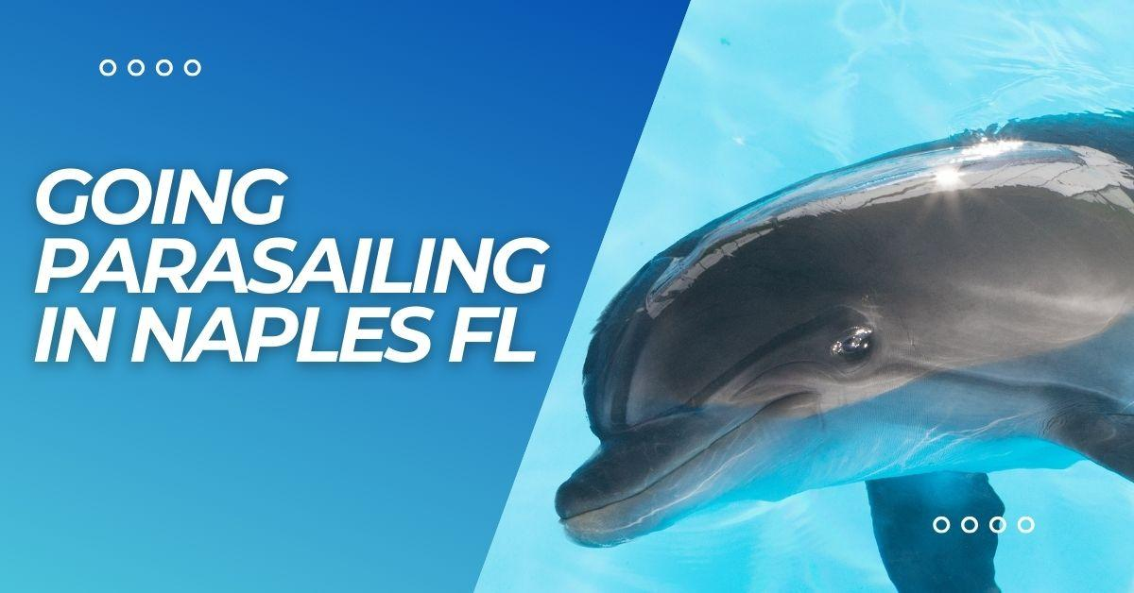

6 Dolphin Tours You Can’t Miss In Naples FL
Now, we will talk about the enchanting world of dolphins you can meet in Dolphin Tours in Naples, Florida.

Naples Florida Dolphin Tours
Naples Dolphin Tours will take you to see dolphins and manatees in the beautiful waters of Southwest Florida. Their Dolphin, Manatee & 10,000 Islands Eco-Tour is a 3-hour family-friendly tour that will take you to the stunning 10,000 Islands with a stop at Whitehorse Key.

Another special tour, the 3-hour sunset cruise offers a romantic setting with the chance to see manatees and wildlife as you travel through the Everglades toward the Gulf of Mexico, while observing a picturesque sunset view, perfect for if you are going as a couple.

You can swim and walk the beach at Whitehorse Key, so bring your beach accessories. Although the boat you will be traveling in has its top fully covered you will be on the island in the sun for about 45 minutes to get some light tan.

Naples Water Tours
Naples Water Tours provides a range of exciting dolphin sightseeing and eco-tours for both single and groups in Naples, Florida. Their tour options include a 2-hour adventure tour, a 1-hour Dolphin Tour, & finally a 1.5-hour Dolphin and shelling tour.

The 2-hour Adventure Tour allows you to go see the dolphins in the gulf, playing and swimming close to the boat. The journey also includes navigating through mangrove forests and estuaries, giving you a serene lagoon experience.

1-Hour Dolphin Tour is a shorter option that still provides an up-close encounter with dolphins. & the 1.5-Hour Dolphins & Secluded Shelling Beach combines dolphin watching with a visit to a pristine beach.

Island Time Dolphin and Shelling Cruise
The Dolphin and Shelling Cruise offers a captivating experience for you in Naples, Florida's stunning waters, particularly in the 10,000 Islands and Keewaydin Island. Starting from $90 per adult, the cruise will typically last around 2 to 3 hours.

In addition, you will see Keewaydin Island, a beautiful barrier island with pristine beaches perfect for shelling, and the 10,000 Islands, a unique group of islands known for their diverse wildlife and stunning scenery.

The cost of their cruises varies depending on the type of experience chosen, such as dolphin tours, shelling excursions, or sunset cruises. There are multiple variations based on the cruise type and season. Also, Pets under 30 pounds will need a pet fee of $100.

Naples Waterway & Wildlife Tours With Water Wuber
Water Wubar has a variety of tours to explore such as the Island Beach, Wildlife Tour, Sunset Cruise, Waterfront Real Estate Tour, and Custom Trips/Tours. The Island Beach tour will take you to Keewaydin Island, and the Wildlife Tour will show you the wildlife of southwest Florida.

You will be going through Naples Bay and the Ten Thousand Islands in the wildlife tour. Then, the Sunset Cruise goes through Naples Bay and Gordon Pass, giving you a chance to see the beautiful sunset over southwest Florida.

You can plan your own trips and tours to go anywhere in the Naples/Marco Island area that can be reached by water. For example, you could have lunch on Marco Island or take a scenic tour of the mansions in Naples Bay. The prices for these trips vary based on the length of time needed.

Three-Hour Dolphin Watch/Eco Tour for One or Two from Pure Florida
If you are traveling alone or just with your significant other, this tour is just the thing you need. Pure Florida covers all three- Dolphin tours, Sunset cruises, and fishing trips for solo travelers and couples as well.

You can spot dolphins during the cruise, as well as take a walk on the beach and look for shells like mollusks and sand dollars all in three-hour eco-tours by Pure Naples. If your rental is around 5th Avenue, you can easily get to their departure location. You can book online too.

Starting at 9 AM, you will be venturing through the mangrove forests and then the Gulf of Mexico in the vessel called Edison Explorer during the eco tour, but the sunset cruises will be later in the afternoon.

Bark on the Ark Dog Cruises
This one is especially for pets. Once a month, Bark on the Ark, a dog-friendly cruise in Naples, Florida takes place on the M/V Edison Explorer ship and goes along Naples Bay to Keewaydin Island for a sightseeing eco-cruise.

The cruise leaves from Naples' Tin City. On the island, you can enjoy the sun, water, sand, and fresh air while your dogs play. Every dog gets a bag with healthy treats, water, a tennis ball, and trash bags. At Keewaydin Island, dogs must be on a leash at all times. So bring your pets.

Learn More About Naples
Discover the perfect home away from home here at Naples Florida Rentals. Enjoy the convenience of being just minutes away from top-rated dolphin tours, pristine beaches, and vibrant local attractions.

Book your stay today and dive into the magic of Naples' coastal wonders! Follow Dana’s Guide To Naples for more awesome places you can visit in Naples.

